Incucyte Live Cell Imaging with siRNA transfection
Keri Lab
Case Western Reserve University

Day 0: plate cells to be transfected *you will need to work backwards in order to determine how many cells need to be plated and transfected in order to have enough cells for incucyte imaging and knockdown confirmation (RNA, and/or protein collection)*
- For this experiment it was typically two 10 cm plates per siRNA treatment with 7.5x10⁵ -1x10⁶ cells/plate using MDA-MB-231 cells (two 10 cm plates for siNS, two 10 cm plates for siLIN9, etc.)
Day 1: transfect cells following normal transfection protocol (we use lipofectamine 2000 protocol)
Day 2: change media on transfected cells
Day 3: move cells into 24 well plate (~40k cells/well for MDA-MB-231) 16-24 hours before your planned incucyte experiment (which will begin on day 4)
- For each siRNA there should be 3 wells of cells (3 wells of siNS, 3 wells of siLIN9, etc.)
- Make sure the cells are evenly distributed at this point, I recommend checking them every 30 minutes or so with some shaking to redistribute until most cells have adhered to the plate
- It is really important not to have extremely confluent cells going into the incucyte or very crowded areas because it will make it difficult to follow cells over time
**NOTE: at our institution it is necessary to sign up for Incucyte well before the actual experiment to get days 4-7 without interruption (I typically plan this period to go from Friday afternoon-Monday afternoon)
Day 4: bring cells to incucyte and image every 10 minutes with a 20X objective
Day 7: stop imaging (can go longer if you would like, this just means more images to process)

Image analysis (your images should be time stamped)
To do this I typically have an excel spread sheet to keep track of cells. Things that I note are:
- the beginning of mitosis- when the cell rounds up. Now this is not always obvious so I usually look for the formation of a metaphase plate (see second image) and then go two frames (20 minutes back) and mark that time as the beginning of mitosis (usually this will coincide with when the cell rounded up).
- The end of mitosis- when the two daughter cells flatten back out usually marks the end of apoptosis
- The outcome (fate) of the first mitosis- did the cells exit and die? Exit and divide? One exited and one died? Etc.?
- The outcome of the second mitosis- I try to follow the daughter cells and record what they do during a second mitotic event (some daughter cells may never divide again depending on what you expect for your phenotype)
It is really important to be consistent in when you determine the start of mitosis and end (images should look similar).

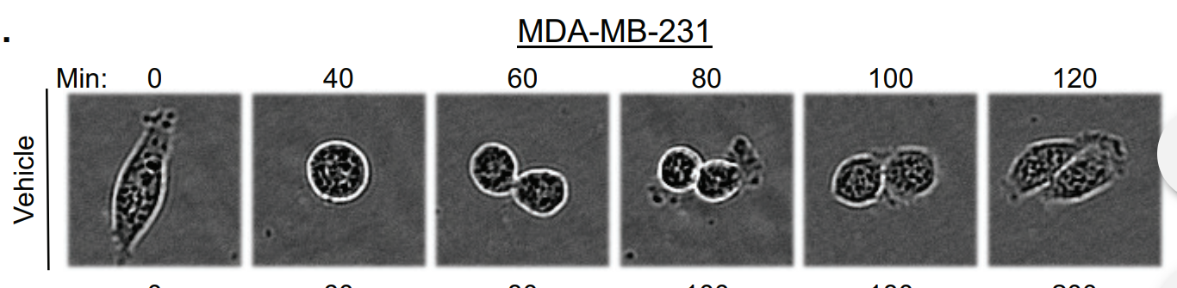
Image 1: Example of a cell going through mitosis from beginning to end[1]
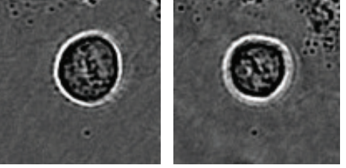
Image 2: example of metaphase plate formation[1]

1. Sahni, J.M., et al., Mitotic Vulnerability in Triple-Negative Breast Cancer Associated with LIN9 Is Targetable with BET Inhibitors. Cancer Res, 2017. 77(19): p. 5395-5408.

