Gel Set Up
Gel 1 Experiment Title(s):
Cell Line(s): Treatment(s):
Time Point(s): Loading volume/total conc.:

 | 1 | 2 | 3 | 4 | 5 | 6 | 7 | 8 | 9 | 10
vol
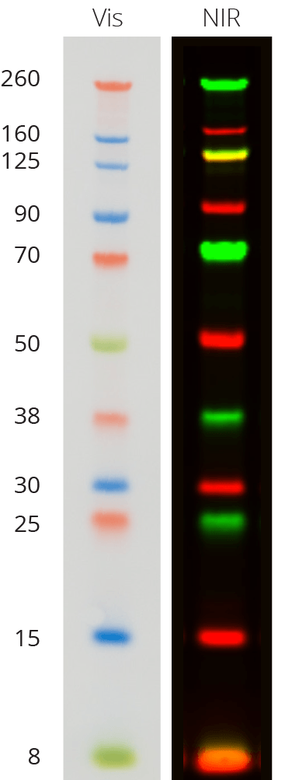

Gel 2 Experiment Title(s):
Cell Line(s): Treatment(s):
Time Point(s): Loading volume/total conc.:

 | 1 | 2 | 3 | 4 | 5 | 6 | 7 | 8 | 9 | 10
vol

Day 1 Buffers/Solutions
10X Running Buffer Running Buffer Transfer Buffer (20%MetOH)
30.25g Tris Base (MW121) 100mL 10x Running Buffer 100mL 10X Running Buffer
144.25g Glycine (MW 75.07) 5mL 20% SDS 200mL MetOH
Up to 1L with distilled water Up to 1L with distilled water Up to 1L with distilled water

Prepping Samples
- Samples are already prepped at 1ug/uL stocks and stored in the -20C
- Thaw samples in 37C for 5 min
- Boil samples on heat block (set at 100C) for 5 min
Prepping Mini Gel Tank and Gel
- Prepared Gel
  - Take out gel from plastic casing and remove white tape located at the bottom
  - Rinse gel with distilled water
  - Place gel in the tank and remove comb slowly
- Add Running Buffer into the chambers (holds ~400mL) to the line
  - Make sure it has overflowed into the side chamber
  - Clamp the gel into place
Loading Samples
- Load samples as shown above
- Ladder: Chameleon Duo (Licor: 928-60000)
  - ~5-10uL
- Run at 200V for 35-45 min until dye reaches the bottom
- Meanwhile, go through steps 10-13
Transfer
- Clean forceps/ sponges/ containers
  - Add 100% MetOH for 5 min, discard in sink, and repeat
  - Quickly rinse with distilled water
- Soak sponges and filters in Transfer Buffer (20% MetOH)
- For PVDF-low fluorescence membrane, activate with 100% MetOH for 15 seconds
- Place membrane in Transfer Buffer (20% MetOH) for 10min or until gel has finished running
- When gel is done, disassemble precast gel and place gel in the Transfer Buffer for 10 min
- Before layering, place gel on top of a filter.
  - Make sure your gel is facing the same direction as you loaded.
- Layer on black side of holder: fiber (sponge), filter with gel, membrane, filter, fiber.
- Add transfer buffer & roll out any bubbles between each layer.
- Place in holder black to black and clear to red.
- Repeat for second gel.
- Fill reservoir with transfer buffer halfway. Take to cold room. Place ice pack. Fill the rest of the reservoir with transfer buffer.

Run 70V for 2Hrs. Can adjust powerbox to have a timer.

REVERT-Total Protein Stain (Licor; 926-11010)
- After transfer, rinse membrane in water
- Incubate in 5mL of REVERT Total Protein Stain for 5 minutes, gently shaking
- Decant solution
- Rinse with ~5mL Wash Solution for 30 seconds, two time
- Image membrane immediately with 700nm channel
- If incubating with two 2 Abs (700 and 800nm channels)
  - Add 5mL of Reversal solution for 5-10min, gentle shaking
  - This is complete when reversal solution is no longer visible by eye
  - No longer than 10min
- Rinse membrane with distilled water
- Proceed to blocking

Blocking
- Add blocking buffer, rocking, RT for 1hr
  - 5% Milk-TBS or PBS (NO TWEEN)
    - Add 2 grams of milk in 40mL TBS (50mL conical tube)
- Wash with TBS for 5 minutes in RT while vigorously shaking
- Mark off: □first wash □second wash □third wash □fourth wash

Primary Antibody
- Dilute antibody in 5% BSA-TBST (WITH TWEEN)
  - Stock 5% BSA-TBST
    - Add 2 grams of BSA in 40mL TBST (50mL conical tube)
- Add antibody to cover the entire membrane
- Incubate overnight in cold room shaking or 1-4hrs, RT, shaking

Wash Membrane
- Remove/Save antibody
- Wash with TBST or PBST for 5 minutes in RT while vigorously shaking
- Mark off: □first wash □second wash □third wash □fourth wash

Secondary Antibody
- Prepare secondary in blocking buffer containing 0.2% Tween and 0.2% SDS (final)
  - This is for PVDF membranes
  - Add 400uL of 20% SDS in 40mL TBST, mix gently, in a conical tube
  - Add 2 grams of milk
- Licor suggests 1:20,000 dilution
  - Range, 1:5000-25000
- Protect membrane from light
  - Use black box or put foil around it

Wash Membrane
- Protect from light
- Remove secondary antibody
- Wash with TBST or PBST for 5 minutes in RT while vigorously shaking
- Repeat 3 times
- Mark off: □first wash □second wash □third wash □fourth wash
- Last wash with TBST or PBST

